MAJOR – SEP

Name – Anjali Kuamri

Email – [anjalirajwar101@gmail.com](mailto:anjalirajwar101@gmail.com)

College Name – BIT Sindri

**Cyber Security Major Project**

5. Use Mobile tracker free (online tool) to install in android mobile phone and try to execute the

commands and taken live webcam stream and screenshots and whatsapp messages. Write a

report on that attack and provide solutions to avoid android hacking

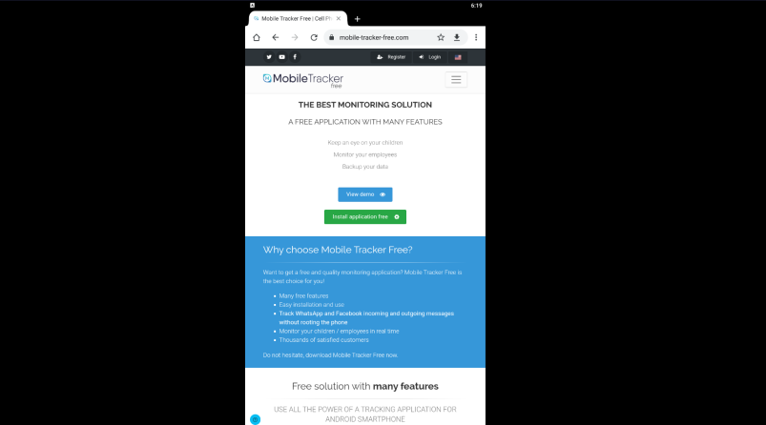

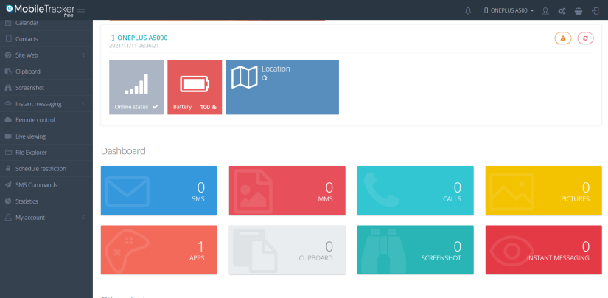

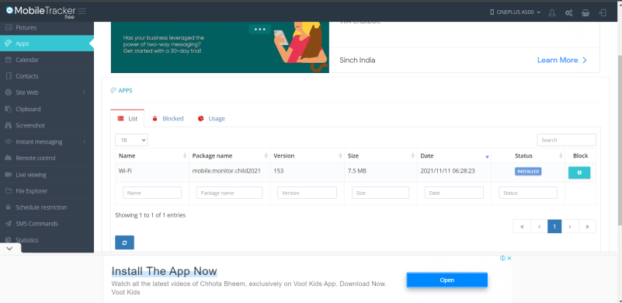

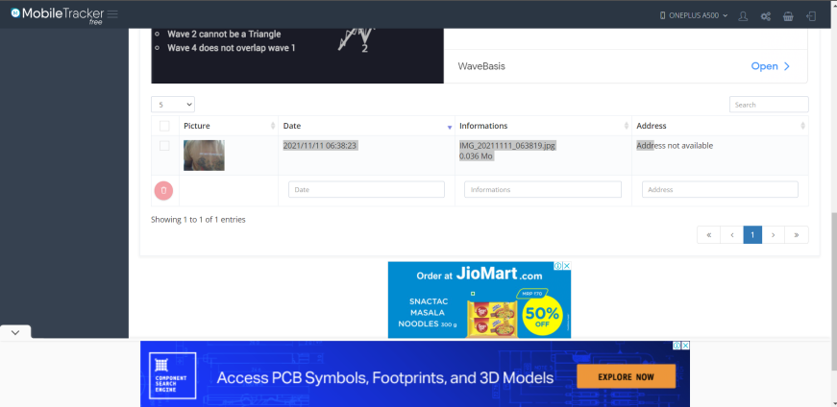



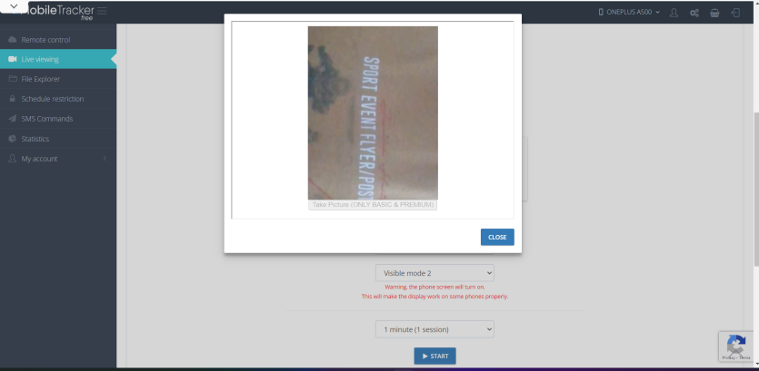

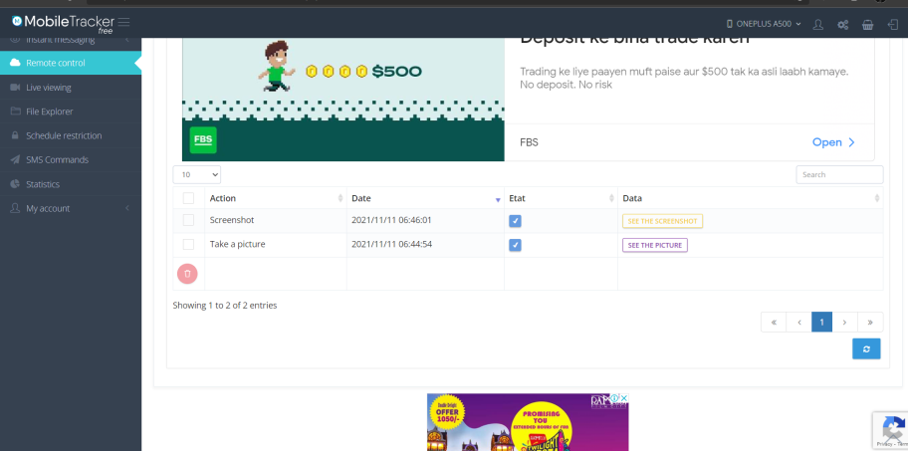



**Basic Phone Security Tips**

1.Never leave your phone unattended.

2. Change your phone’s default passcode

3. Manage your Bluetooth Security

4.Protect your PIN and Credit Card data.

**Advanced Ways to Prevent Phone Hacking**

1. Avoid unsecured public WiFi.

2. Turn off your autocomplete feature.

3. Regularly delete your browsing history, cookies, and cache.

4. Have an iPhone? Enable Find My iPhone.

5. Use a security app that increases protection.